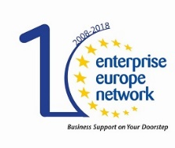

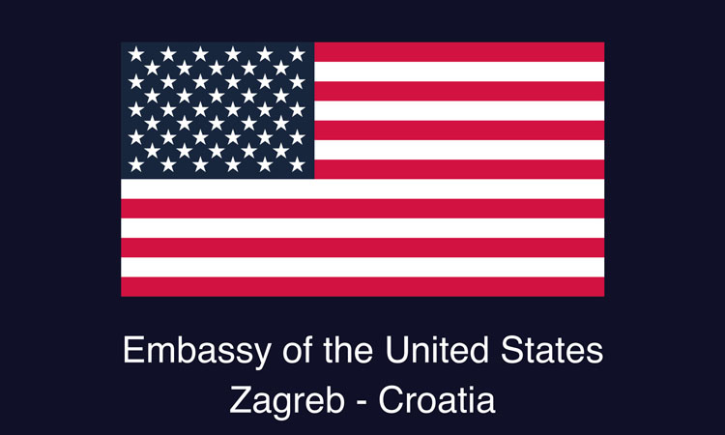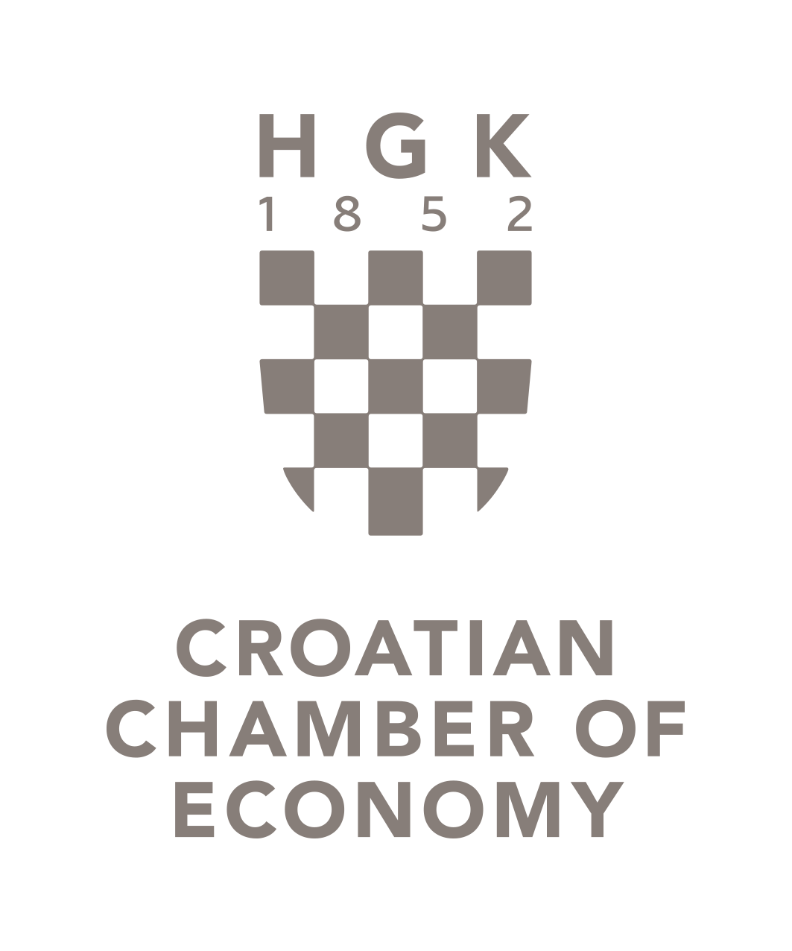

**RON BROWN INNOVATION DAY**

**19 April 2018**

Venue: FORUM Zagreb Congress Center, Radnička cesta 50 – center Green Gold, Zagreb

**PROGRAM**

Draft

**9:00 – 09:30** Registration of participants

**09:30 – 09:45** Introductory speeches

- US Embassy representative

- Croatian Chamber of Economy representative

**09:45 – 10:15** Lecture - US entrepreneurship success story

– Mr. Bruce Leech, Executive Director, DePaul University Entrepreneurship Center

**10:15 – 10:30** Presentation – Croatian success story: Amphinicy Technologies

– representative of the Amphinicy Technologies company

**10:30 – 11:00** Coffee break

**11.00 – 11.45** Panel discussion: *Tackling the Entrepreneurship and Innovation Challenge in Croatia: Networking & Partnerships*   
- panel moderator: Tina Lee Odinsky-Zec, PhD; panel participants:

* Mr. Bruce Leech, Executive Director, DePaul University Entrepreneurship Center
* Tihana Petričević, CEO, Studio Rebus j.d.o.o. (Meridda high tech health gadget)
* a representative from Croatian freelance sector (TBD)
* Jana Blažević Marčelja, Deputy Director and Education Center Manager, Advisor for launching an entrepreneurial venture and price strategies, STEP RI

**11.45 - 12.00** Presentation on possibilities for funding for SME’s through HAMAG BICRO and other institutions;  
Technology Partnerships through Enterprise Europe Network (EEN)

– Vedran Đidara, Head of Beneficiaries Support Unit at HAMAG-BICRO

**12:00 – 12.15** Internationalization of SMEs – funding and support through CCE and other institutions;   
Business Partnerships through Enterprise Europe Network (EEN)

– Igor Bobek, Senior Expert Associate, International and EU Affairs Sector, CCE

**12:15 – 12:35** Presentation of the experience in the participation of the US State Department Professional Fellows Program implemented by World Chicago   
– Mr. Tomislav Barbarić, Manager of the Center for Entrepreneurship Osijek and PFP Alumni

**12.35 – 12:45** Closing remarks

**12:45 – 14:00** Buffet Lunch

**Moderator: Ms. Jelena Dumičić, Senior Expert Associate, International and EU Affairs Sector, CCE**

**Working Language: English**