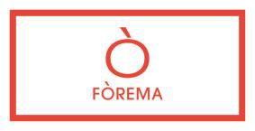
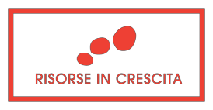

Project Nr 399-1-1284-2016

STRATEGIC SKILLS TO COMPETE IN THE INTERNATIONAL MARKETS

Workshop TRANSNATIONAL SEMINAR
SME’S COOPERATION POTENTIAL & OPPORTUNITIES THROUGH EUROPEAN FUNDING SCHEMES

Friday September 29 2017
14:00 - 18:15
c/o UNISEF LAB - Via Venzone, 12 – 31100 Treviso (TV)

The Seminar will focus on concrete examples of support actions in the field of internationalization. Based on the experience of the “EXPORT ACADEMY” which has been activated by some of our project partners, the workshop will describe concrete examples of how transnational cooperation can help SMEs to jointly analyse and enter new markets.

The workshop will also provide the base to introduce some new project ideas which will be activated over the next 3 years. Therefore, the second part of the workshop will aim at exchanging ideas and priorities with the participating enterprises with a view to understand their potential interest for future action.

Programme
13:45  14:00  14:15  15:00  15:15  16:30 | Welcome and Registration Introduction (UNISEF Scarl & Fòrema)  Internationalization: European Projects as a means to discover new markets - A. JESTER  Participants’ feedback  Transnational Case Studies: Examples and Case Studies of internationalization actions targeted to SMEs:  Mind Consult & Research Gmbh - Austria - W. SCHRITTWIESER  Croatian Chamber of Economy – R.PAPEC, K. MIKSAJ  GZS Slovenia – M.OSOJNIK  Participants’ feedback
16:45 | Coffee Break
17:00 | Italian Case Studies: Examples from Emilia Romagna and Lombardia - A. JESTER
17:30 | Exploring future cooperation potential between Italy, Austria, Slovenia and Croatia
18:15 | End of workshop

