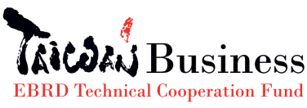
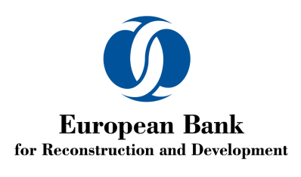

Application Form
EBRD Business Matching Trip for Croatian Women in Business 2017
September 27-October 01, 2017 Taipei
Delegate name |  | Email
Title |  | Telephone/Mobile
All fields are required and must be completed to process the application.

- Company information
Company Name |  | Year Established
Company Address |  | Tel. | +385
2015 annual turnover (EUR) |  | OIB: Company identification no.
2016 annual turnover (EUR) |  | 2017 no. of Employees
Industry sector
Manufacturing or Services (please underline)
Do you currently export? Y/N
Value of export in 2015 and 2016 (EUR)
Name main export countries

Does your company currently export/import from/to South East Asia? Please list the countries.

Does your company currently export/import from/to Taiwan? Please list the products and/or services and names of partners

- Company profile
Please describe your company, products, and services.
- Aspiration on the Business Matching Trip to Taipei
Please outline your main expectations form this BMT? What would you like to achieve?
Please list and describe products or solutions you are interested in investigating/purchasing during the BMT
Please list and describe products or solutions you are interested in promoting/selling during the BMT:
Please list names of companies or types of companies you would like to have one-to-one meetings with: | Justification
1.
2.
3.

